Weekly Letter
English I
Week 11 ---second quarter begins
October 24-28
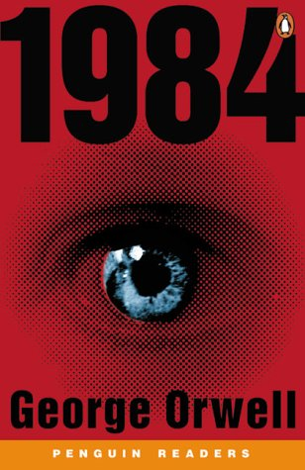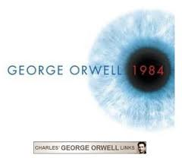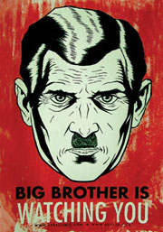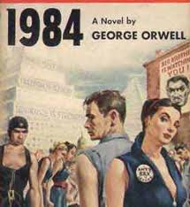
Background:
Nineteen Eighty-Four (1984) by George Orwell is a classic dystopian novel--an eerily prescient of the state of modern society. Written by a liberal and fair-minded socialist soon after the end of the second world war, 1984 describes the future in a totalitarian state where thoughts and actions are minutely monitored and controlled. Orwell gives us a drab, empty, over-politicized world. With the passionate individualism of the central character, revolt is a very real danger.
Genre: Science Fiction
a. a literary genre that makes imaginative use of scientific knowledge or conjecture
b. ( as modifier ): a science fiction writer

Cultural Dictionary

science fiction definition

Works of fiction that use scientific discoveries or advanced technology — either actual or imaginary — as part of their plot. Jules Verne and H. G. Wells were early writers of science fiction. More recent ones are Isaac Asimov and Ray Bradbury.

Famous Quotations
"Science fiction writers foresee the inevitable, and alt..."

Free Website to Read Online:
http://www.george-orwell.org/1984

--------------------------------------------------------------------------------------------------------------------------------
M: No School: Teacher PD Day

T: Weekly Letter
Independent Reading
Journal #1
The sentence, “BIG BROTHER IS WATCHING YOU,” has become a part of our modern language. What does it mean to you? Explain a situation in which you used those words in a conversation with a friend.
Distribute article:
Begin reading and answering questions on the article: (printed and on website)
"How Companies Learn Your Secrets" article with questions

W: Independent Reading
Finish "How Companies..." and submit by end of period
HW: Read article about Pennsylvania school webcams (printed and on website)

TH: Discuss HW webcam article
Three mini videos : totaling just three minutes on how the NSA spies on Americans:
https://www.youtube.com/playlist?list=PL_pPc6-qR9ZwtxgKf7QiecYtp_uNSK5Eg
Journal #2
The three Party slogans on the side of the building are paradoxes: WAR IS PEACE FREEDOM IS SLAVERY IGNORANCE IS STRENGTH. A paradox is a statement that on the surface seems to be self-contradictory but in another sense may be true. Write about how in what sense each of these contradictory statements could be true.
HM: Read: "So Are We Living in 1984" article (printed and on website)

F: Independent Reading
Preview 1984 and distribute study guide, character list, Oceania map, vocabulary, reading calendar
HW: Bring 1984 to begin reading on Monday, 10/31!!

- 